**Business Analysis Report**

**Jakarta's Food and Beverage Service Industry**

**Prepared by:** Rabbi Islam Yeasin  
**Credentials:** IBM Certified Professional Data Scientist | Business Analyst

**Executive Summary**

This report provides an analytical overview of the food and beverage service industry in Jakarta, utilizing a comprehensive dataset from 2014. The study explores the business types, capacity trends, regional preferences, and leading businesses and directors, offering actionable insights for stakeholders in the culinary sector.

**Scope of Analysis**

The dataset comprises key information about restaurant businesses in Jakarta, including:

1. Business Names and Addresses
2. Business Corporations and Owners
3. Regional Distribution and Contact Information
4. Business Types and Capacities

**Insights and Findings**

**1. Popular Business Types**

* **Dominance of Restaurants:** Restaurants outpace other business types, including cafes and alternative culinary ventures, in both presence and popularity.

**2. Regional Preferences**

* **South Jakarta's Leadership:** As a culinary hotspot, South Jakarta surpasses Central Jakarta in hosting popular and successful franchises.
* **Key Locations:** Grand Indonesia emerges as a favored venue for franchise businesses, attracting significant consumer traffic.

**3. Top Culinary Business and Directors**

* **Prominent Franchise:** Kentucky Fried Chicken (KFC) leads as the most preferred franchise in Jakarta.
* **Influential Leader:** Carolina Susanty is recognized as a notable figure directing popular franchises in the region.

**4. Room Capacity Preferences**

* **Common Capacity Usage:** The "10/40/B" room configuration is the most utilized capacity setup for culinary businesses, suggesting a strategic alignment with consumer demand and business operations.

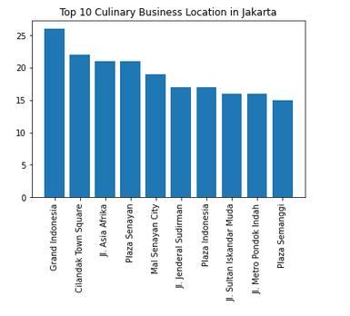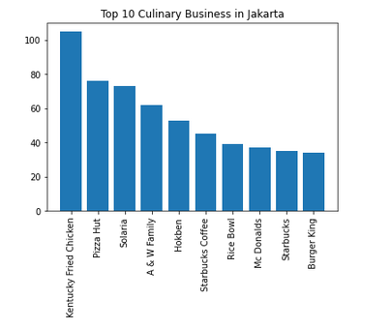

**Data Quality Assessment**

**Missing Values Analysis**

* Missing value ratios were analyzed and visualized using pie charts to identify gaps in the dataset, ensuring a robust understanding of the available data.

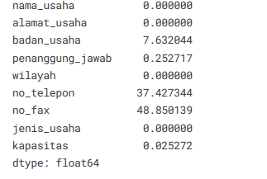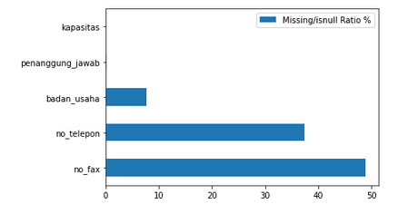

Missing Value Percentage

Missing Value Ratio

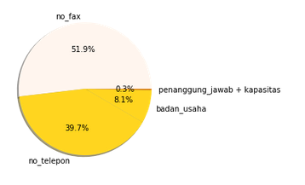

Missing Value Plot in Pie Chart

**Business Implications**

1. **Strategic Expansion:**  
   Investors and entrepreneurs are advised to consider South Jakarta for new ventures due to its consumer density and business-friendly environment.
2. **Franchise Success Factors:**  
   Aspiring franchisees may benefit from studying the operational models of leading businesses such as KFC.
3. **Capacity Optimization:**  
   Adopting the "10/40/B" room capacity standard can enhance customer satisfaction and operational efficiency.

**Conclusion**

This analysis demonstrates the dynamic nature of Jakarta's food and beverage industry, highlighting growth opportunities and strategies for success. The insights can guide business decisions, contributing to a thriving culinary market in Jakarta.

For further collaboration or consultation:

**Rabbi Islam Yeasin**

**CSE Graduate, UIU | IBM Certified Professional Data Scientist**

[**Email**](mailto:official.rabbiyeasin@gmail.com) **|** [**LinkedIn**](https://www.linkedin.com/in/rabbiyeasin/) **|** [**website**](rabbi.yeasin-arena.com/)